www.pattyhall.com PATTY HALL www.pattyhall.com
NATIVE DAUGHTER OF THE GOLDEN WEST®

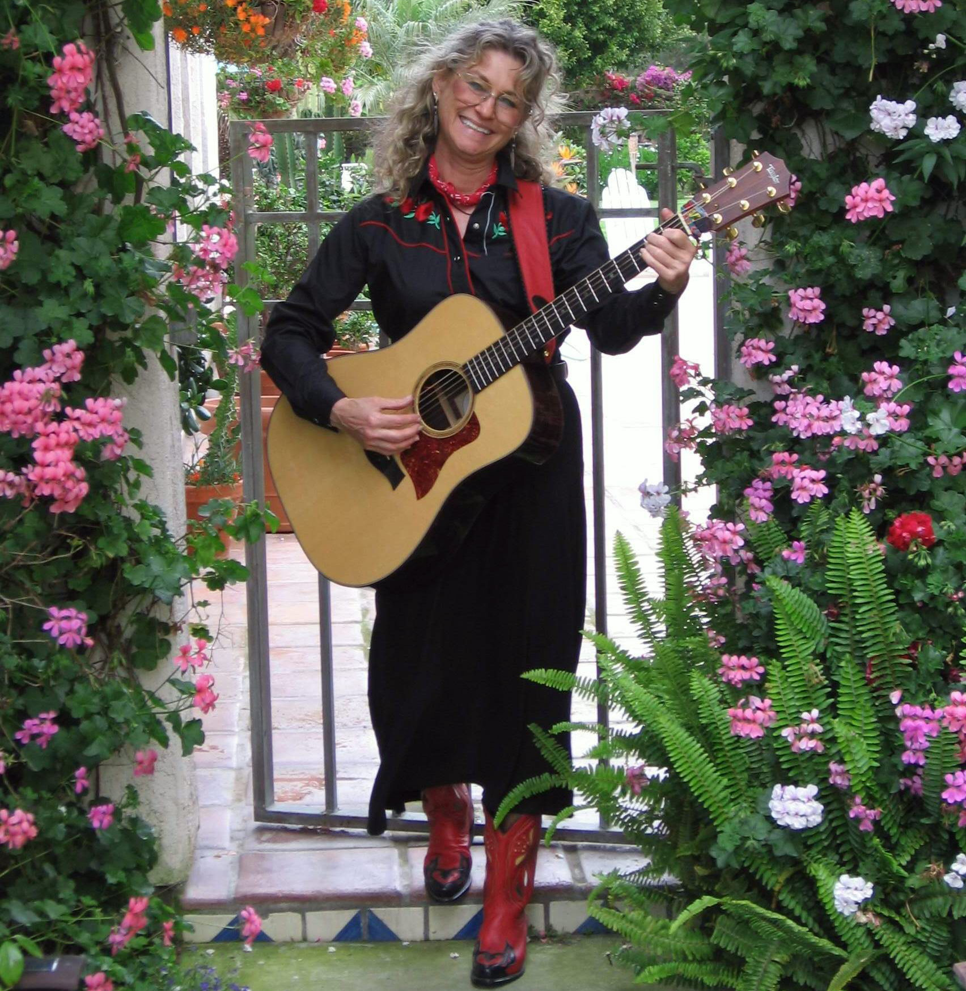

BORDERS BOOKS & MUSIC - VACAVILLE

11641 East Monte Vista Ave. – Vacaville – CA

SATURDAY - SEPTEMBER 23, 2006
7-9 PM

Come out to BORDERS BOOKS & MUSIC – VACAVILLE to hear San Diego singer/songwriter/folklorist/author PATTY HALL share her best and newest NATIVE DAUGHTER® music--a unique blend of traditional and original material rendered on guitar, banjo, and a cappella. Her CD, JUST BE GLAD! will be available for sale. For more info, visit:
www.pattyhall.com



